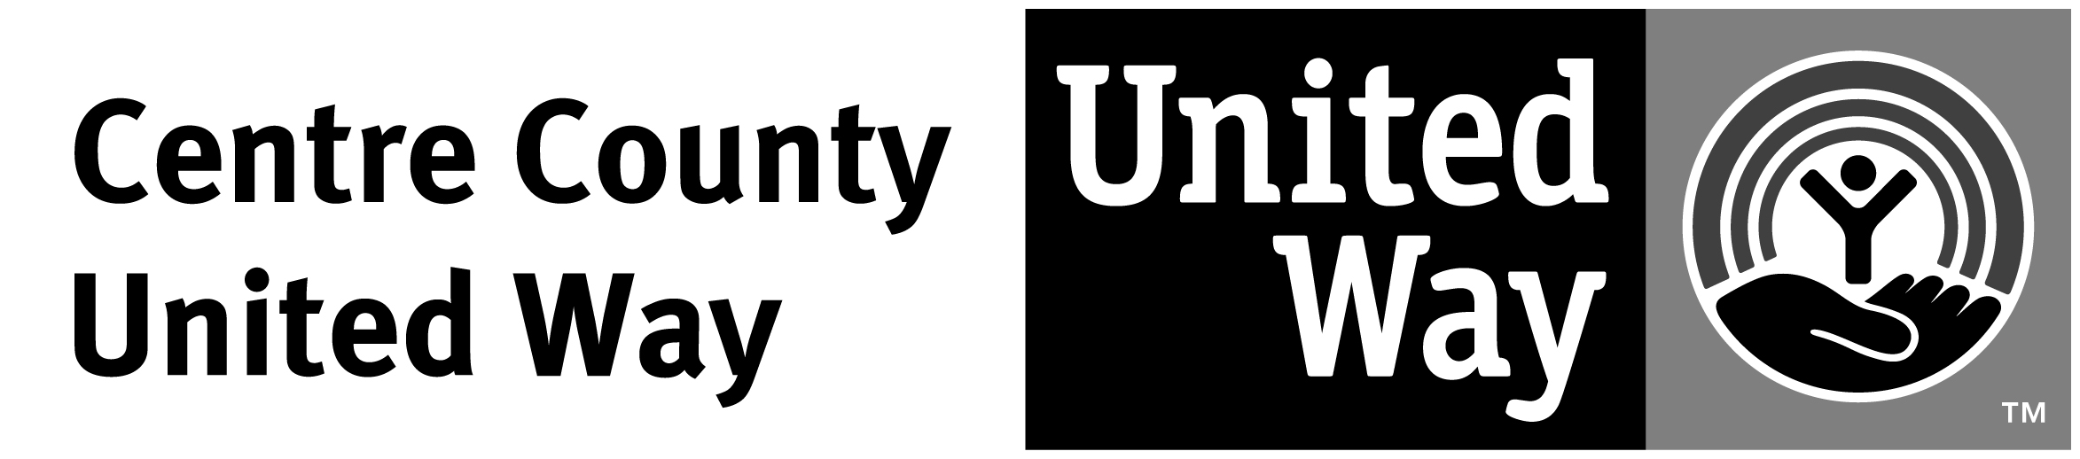
PENN STATE SPECIAL EVENT REPORT FORM

Date: |  |  |  | Would you like a receipt mailed to you?
Department: |  |  |  |  |  |  | Unit #:
Contact: |  |  |  |  | Campus Phone: |  |  | Email:
Campus Mailing Address:
Event Description:

CASH REPORT:
Total Raised: | $ | Less Expenses | $ | Amount Submitted | $

BREAKDOWN:
CURRENCY TYPE | QUANTITY | TOTAL
A. Checks
 | (A) Total Amount in Checks
B. Cash:
$100
$50
$20
$10
$5
$1
(B) Total Amount in Cash
C: Coins:
$1
$.50
$.25
$.10
$.05
$.01
(C) Total Amount in Coins
(D) Credit Cards
(E) Grand Total
IN-KIND SUPPORT:
VENDOR | $ VALUE

Please take this form and your special event money to: Centre County United Way
126 Pine Grove Road, PO Box 664
814.238.8283 or info@ccunitedway.org
United Way will submit this report to Barb Ettaro.

Please roll coins or take to PNC Bank on College Ave. They will give you cash for your coins.

